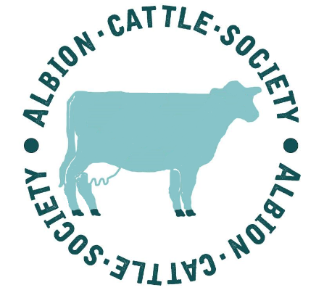
Newsletter: 6th October, 2017

The Albion Cattle Society meeting held at Cumbrian Wildlife Office, near Windermere in the Lake District, on 15th July, 2017.
As Albion keepers and breeders are few and far between, stretching from Cornwall and Kent right up to Cheshire and Cumbria, it is rare to have the opportunity to hold a meeting. This meeting was combined into a special Albion weekend, holding an informal supper on the Friday evening courtesy of the National Trust, followed by an open meeting on the Saturday morning, with a herd visit in the afternoon to view the beautiful Scout Beck herd of Albions.

Attendees of the Albion Meeting:
Susannah Mannerings Alan & Leona Mills
Bob & Dan Cowell Ruth Dalton
John Ball & Lynn Parks David Clegg
Colin Nankervis John Pring
Alan & Lili Kersey Julian Stevens
Richard Hodgson Fiona Green
After an introduction from Ruth Dalton and a very informative talk supported with some interesting literature on the history of the Albions up to the current situation by Susannah Mannerings, there followed an open discussion with several points covered, one of the main outcomes was the voting in of an official Albion Society Committee.

Office Holders.
Chairman: John Ball- Proposed by Susannah Mannerings, seconded by Julian Stevens.
Secretary: Susannah Mannerings- Proposed by Colin Nankervis, seconded by John Ball.
Treasurer: Lynn Parks- Proposed by Leona Mills, seconded by Colin Nankervis.
Committee Members: Colin Nankervis and John Pring.

-It was felt that some funds needed to be raised, starting by charging a membership subscription.
-It would be good to send another bull for semen collection.
-More evidence needs to be found for the proof of existence of Albions in the late 1960s through to the early 1980s – the gap that needs to be filled before RBST can take a serious assessment to see if Albions can be accepted on to their list of ‘at risk’ breeds.
- Promote the breed more; (a small mention on Countryfile at the end of September has increased the website viewings by 1000, with 3 new people enquiring about buying stock.)
FOR SALE.
Alan Hewson, Melton Mowbray. 01949 860242 (Cattle below about to have TB test)
Albion bull: Speckles Jonas , blue, 2010 correct conformation & lovely temperament, from a milky line.
Albion bull: Ironstone Blue John, blue, 22/7/2016
Albion 4th calver: Speckles Deluge, 2010, blue, approx. 4/5 mths IC to Sp Jonas
WANTED.
Julia Botham, Derbyshire. 07756 668221 Looking to purchase after Christmas.
Anne Cockram, Bolton, Lancs. 01204 697001 Looking for a young cow or heifer or a couple of heifer weanlings.
Also: a request for a source of Albion meat within 100 miles Skipton!
Please contact Susannah Mannerings 07733 419685 if you can help over this.

- - - - - - - - - - - - - - - - - - - - - - - - - - - - - - - - - - - - - - - - - - - - - - - - - - - - - - - - - - - - - - - - - - - - - - -
Please cut out, fill out and post back:
Name:
Address:

E-mail:
Tel:
Subscription: £15-00 ( All paid up members will be sent an enamel badge.)
Optional Additional Donation:
Please enclose cheque payable to ‘The Albion Cattle Society’ and post to:
Mrs S. Mannerings, Chilton Farm, Alkham, Dover, Kent. CT15 7DR
(E-mail: srmannerings@gmail.com)

